Game Design Document

Team: Mazeland

# **Game Overview**

## *Game Concept*

This is a maze game where the player is trying to find the legendary treasure underneath the evil temple.The game will be composed of several floors of 2D mazes for the player to explore. The player will move in grids and encounter enemies, interact with items, and find treasures. The player will go to deeper floors to advance the levels and encounter more difficult challenges and better treasures.

*Target Audience*

Players who are fascinated by the rogue and maze game.

*Genres*

Dungeon Crawler; Rogue; Action Adventure

# 

# **Team**

Programmer, UX Design; Vision Control, Audio Control

| Name | Email |
| --- | --- |
| Shibo Zhang(Team Captain，Programmer) | shibozha@usc.edu |
| Mingdong Lyu(Product manager; UX Design) | mingdonl@usc.edu |
| Zifeng Lin (Analytics) | zifengli@usc.edu |
| Xiujing Huang (Programmer) | xiujingh@usc.edu |
| Tianding Zhang(programmer) | tianding@usc.edu |
| Yintang Yang (Programmer) | yintangy@usc.edu |
| Yang Zhang（UX design, Analytics, programmer ） | yangz673@usc.edu |
| Chuanshi Zhu(programmer) | zhuchuan@usc.edu |
| Ruize Zhang(Product manager) | ruizezha@usc.edu |
| Minzhi Zhan(Analytics) | minzhizh@usc.edu |
| Jerzy Ramos Chen(Programmer) | ramosche@usc.edu |

# **Demos**:

https://github.com/Samberg-0808/Mazeland/blob/main/README.md

# **Prototype1**

Member: Yintang Yang, Xiujing Huang, Chuanshi Zhu

Top-down view. Can move from one map to another if the character has enough coins. The coins can be obtained by collecting in the map or killing the mobs. Can spend the coin to buy magic items/consumables in the mysterious store. (Hiding secret room at each floor )

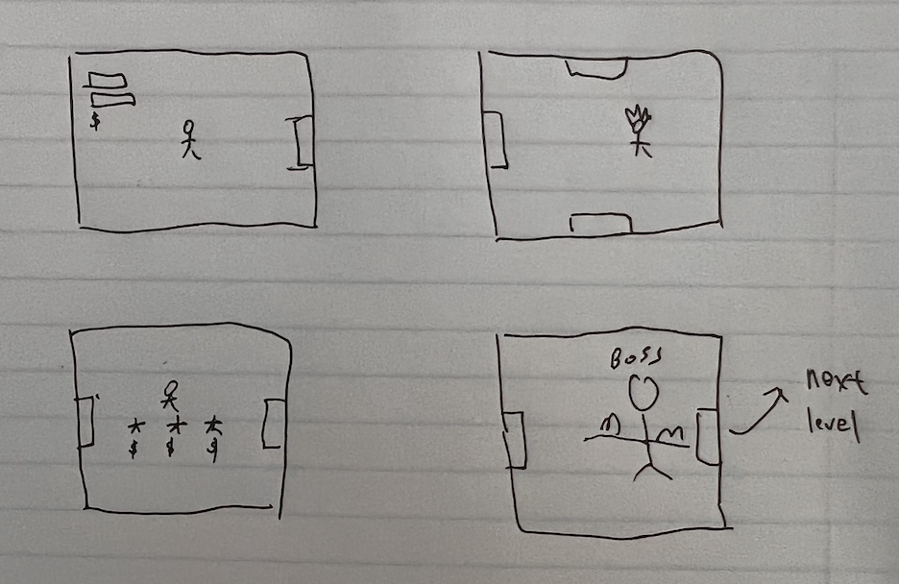

# 

# **Prototype2**

Member: Shibo Zhang, Mingdong Lyu, Ruize Zhang, Zifeng Lin

Side view platformer. Avatar needs to kill all enemies to get to the next map. Player uses the keyboard to control the avatar to kill enemies. And the player needs to watch out for damage from the enemies.

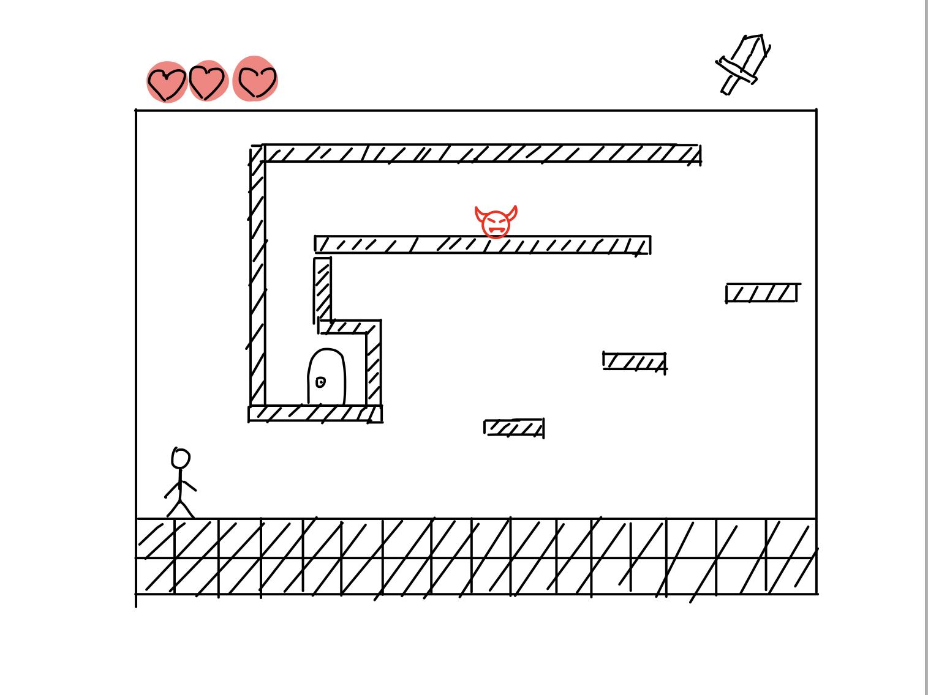

# 

# 

# **Prototype3**

Member: Tianding Zhang, Yang Zhang, Minzhi Zhan, Jerzy Ramos Chen

Top-down view. The player starts at position S, finds the key, and chooses a door to unlock. If the door is not fake, the player escapes successfully and goes to the next map.We can give players some challenges in step1 and step2.

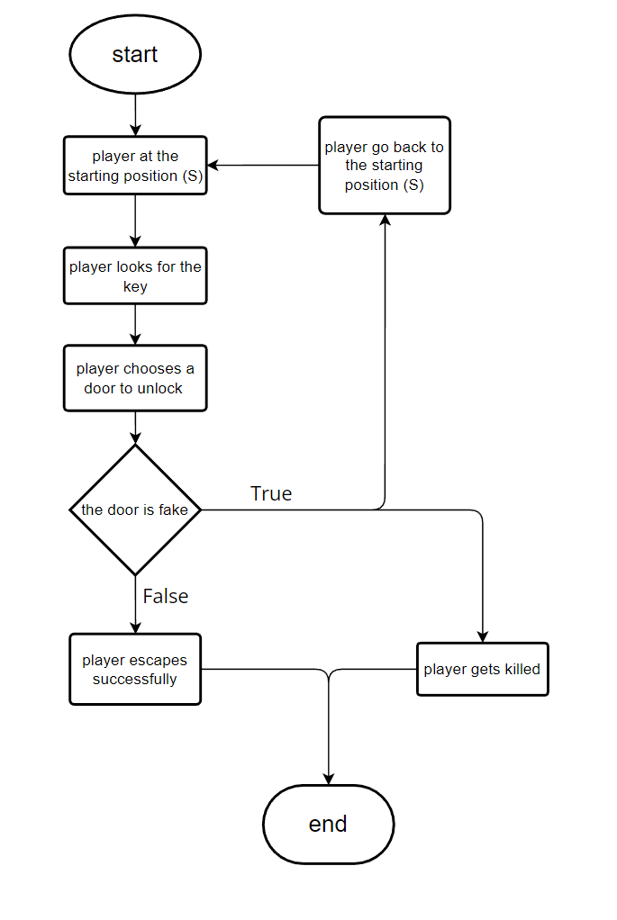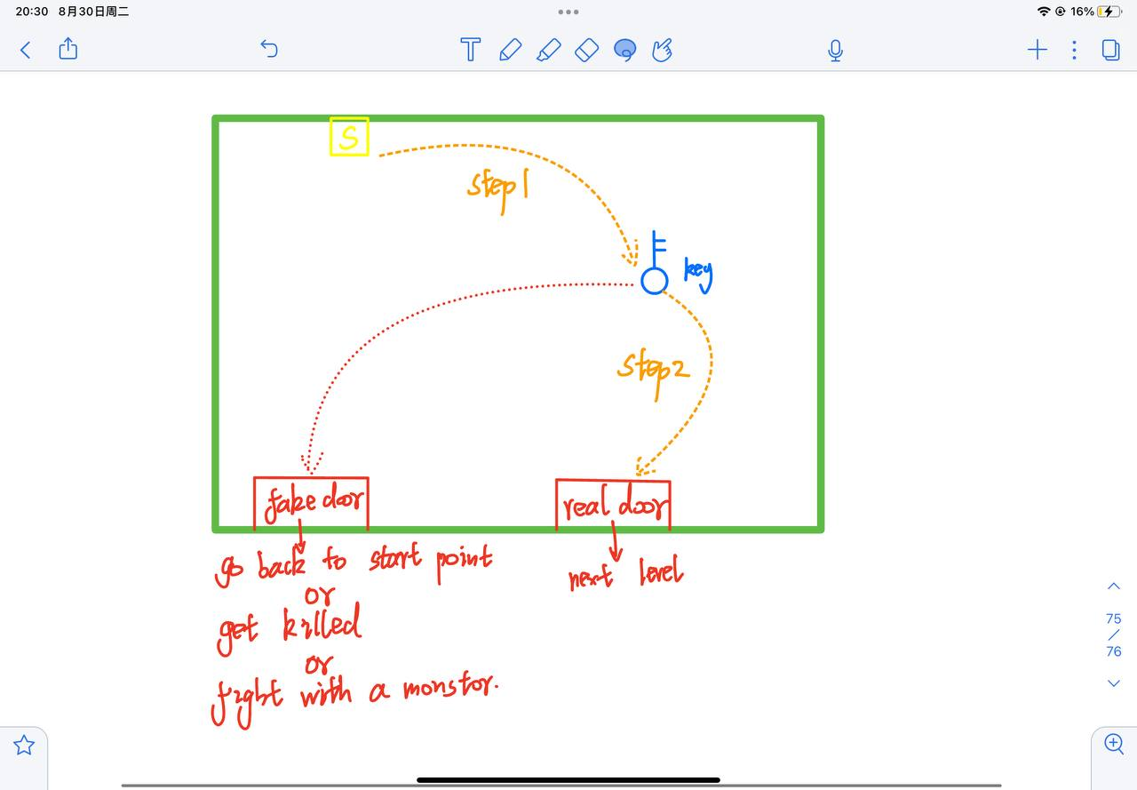

# 

# **Analysis**

# 

# 

# 

# 

# 

# 

# **Interface**

## *Audio*

# Description of the music of your game? What kind of sound FXs do you need?

## *HUDS*

# How do your menus look? What is the interaction and transition between them?

## *Controls*

# Arrow keys. The character can move four different directions.

# Users can use WASD or up/ down /right/ left to control the direction and movement according to their own preference. Movements in every floor are fixed or not in different prototypes. Map is blind and needs to be discovered when the player moves.

## *Art Direction*

# A description of the arty style and approach you plan to use in the game. Describe what the game will look like, and what art or programming techniques you can use to generate a distinctive visual style. It is generally a good idea to mention other games, movies, or other things that the game might look like.

# 

# **Technical Specification**

# What is your target platform? What game engine are you planning to use? Do you have any additional hardware requirements? Do you have any networking requirements?

# 

# 